**Structures of the datasets:**

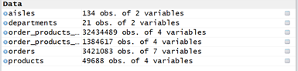

**Libraries used:**

* ouliers
* readr
* ggplot2
* dplyr
* scales

# Display structure of datasets

str(order_products_prior)

str(order_products_train)

str(products)

str(orders)

str(departments)

str(aisles)

***Output:***

*str(order_products_prior)*

*Classes ‘tbl_df’, ‘tbl’ and 'data.frame': 32434489 obs. of 4 variables*

*$ order_id : int 2 2 2 2 2 2 2 2 2 3 ...*

*$ product_id : int 33120 28985 9327 45918 30035 17794 40141 1819 43668 33754 ...*

*$ add_to_cart_order: int 1 2 3 4 5 6 7 8 9 1 ...*

*$ reordered : int 1 1 0 1 0 1 1 1 0 1 ...*

*str(order_products_train)*

*Classes ‘tbl_df’, ‘tbl’ and 'data.frame': 1384617 obs. of 4 variables:*

*$ order_id : int 1 1 1 1 1 1 1 1 36 36 ...*

*$ product_id : int 49302 11109 10246 49683 43633 13176 47209 22035*

*$ add_to_cart_order: int 1 2 3 4 5 6 7 8 1 2 ...*

*$ reordered : int 1 1 0 0 1 0 0 1 0 1 ...*

*str(products)*

*Classes ‘tbl_df’, ‘tbl’ and 'data.frame': 49688 obs. of 4 variables:*

*$ product_id : int 1 2 3 4 5 6 7 8 9 10 ...*

*$ product_name : chr "Chocolate Sandwich Cookies" "All-Seasons Salt" "Robust Golden Unsweetened Oolong Tea" "Smart Ones Classic Favorites Mini*

*$ aisle_id : int 61 104 94 38 5 11 98 116 120 115 ...*

*$ department_id: int 19 13 7 1 13 11 7 1 16 7 ...*

*> str(orders)*

*Classes ‘tbl_df’, ‘tbl’ and 'data.frame': 3421083 obs. of 7 variables:*

*$ order_id : int 2539329 2398795 473747 2254736 431534*

*$ user_id : int 1 1 1 1 1 1 1 1 1 1 ...*

*$ eval_set : chr "prior" "prior" "prior" "prior" ...*

*$ order_number : int 1 2 3 4 5 6 7 8 9 10 ...*

*$ order_dow : int 2 3 3 4 4 2 1 1 1 4 ...*

*$ order_hour_of_day : chr "08" "07" "12" "07" ...*

*$ days_since_prior_order: num NA 15 21 29 28 19 20 14 0 30 ...*

*> str(departments)*

*Classes ‘tbl_df’, ‘tbl’ and 'data.frame': 21 obs. of 2 variables:*

*$ department_id: int 1 2 3 4 5 6 7 8 9 10 ...*

*$ department : chr "frozen" "other" "bakery" "produce" ...*

*> str(aisles)*

*Classes ‘tbl_df’, ‘tbl’ and 'data.frame': 134 obs. of 2 variables:*

*$ aisle_id: int 1 2 3 4 5 6 7 8 9 10 ...*

*$ aisle : chr "prepared soups salads" "specialty cheeses" "energy*

# Data treatment

# Missing value analysis

apply(orders,2, function(x)sum(is.na(x)))

***Output:***

*order_id user_id eval_set order_number*

*0 0 0 0*

*order_dow order_hour_of_day days_since_prior_order*

*0 0 206209*

# orders$days_since_prior_order has 206209 missing values

# Outlier Analysis

library(outliers)

outlier(orders$days_since_prior_order, opposite=FALSE)

#Grubbs test for outliers

grubbs.test(orders$days_since_prior_order, type = 10)

# outliers: day 30 - No extreme outliers found

***Output:***

*Grubbs test for one outlier*

*data: orders$days_since_prior_order*

*G = 2.0512, U = 1.0000, p-value = 1*

*alternative hypothesis: highest value 30 is an outlier*

*# Imputing missing values not required since missing values mean that some users did not reorder some products*

#---------------------------------------------------------------------------------------------------------------------

# Predictive data analysis

# Visualisation

library(ggplot2)

library(dplyr)

library(scales)

# Hour of day

ggplot(data=orders,aes(x=order_hour_of_day)) +

geom_area(stat="count",fill="goldenrod2",colour = "red",size=1.2)+

ggtitle(' No of orders at each hour')+ theme_bw()+

xlab('Order hour of the day') + ylab('No of orders') +

scale_x_continuous(breaks=pretty_breaks(n=24))+

scale_y_continuous(breaks=pretty_breaks(n=7))

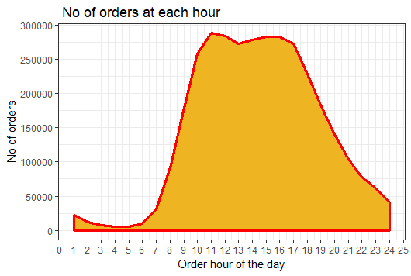

# Day of Week

ggplot(data=orders,aes(x=order_dow))+

geom_histogram(stat="count",fill="grey",size=1.2, colour = "pink") +

ggtitle('No of orders per day')+ theme_bw()+

xlab('Days of Week') + ylab('No of orders')+

scale_x_continuous(breaks=pretty_breaks(n=7))+

scale_y_continuous(breaks=pretty_breaks(n=7))

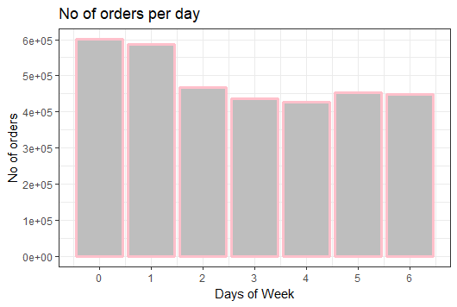

# Days taken to reorder

ggplot(data=orders,aes(x=days_since_prior_order))+

geom_density(stat="density",fill="steelblue1",colour = "goldenrod2",size=1.05) +

ggtitle('Days taken to reorder') + theme_bw() +

xlab('Days since previous order') + ylab('No of orders')

scale_x_continuous(breaks=pretty_breaks(n=15))+

scale_y_continuous(breaks=pretty_breaks(n=7))

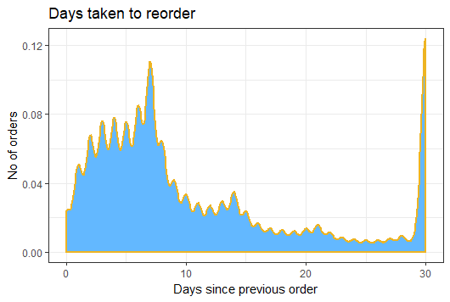

# Retrieve test data from orders

test = orders[orders$eval_set=="test",]

***Output***

*head(test)*

*# A tibble: 6 x 7*

*order_id user_id eval_set order_number order_dow order_hour_of_day days_since_prior_order*

*<int> <int> <chr> <int> <int> <chr> <dbl>*

*1 2774568 3 test 13 5 15 11*

*2 329954 4 test 6 3 12 30*

*3 1528013 6 test 4 3 16 22*

*4 1376945 11 test 8 6 11 8*

*5 1356845 12 test 6 1 20 30*

*6 2161313 15 test 23 1 09 7*

# Retrieve prior users with prior and test by their user_id

# Create temporary dataframes by left join with products

products_aisles = left_join(products, aisles, by = "aisle_id")

products_dept = left_join(products, departments, by = "department_id")

products_aisles_dept = left_join(products_aisles,products_dept, by = "product_id",copy=FALSE)

# Remove redundant columns

products_aisles_dept = products_aisles_dept[,c(1,2,3,4,9,5)]

# Rename the columns

colnames(products_aisles_dept) = c("product_id","product_name","aisle_id", "department_id","department","aisle")

# Remove the temporary dataframes

rm(products_aisles, products_dept)

# Rearrange and group by order_id

orders_train = left_join(order_products_train, orders, by = "order_id")

orders_prior = left_join(order_products_prior, orders, by = "order_id")

# Rearrange and group by product_id, remove redundant columns

orders_train = left_join(orders_train, products_aisles_dept,by = 'product_id')

orders_train = orders_train[,c(-11, -14, -15)]

orders_prior = left_join(orders_prior, products_aisles_dept,by = 'product_id')

orders_prior = orders_prior[,c(-11, -14, -15)]

#row bind train and prior data with all order columns

orders_train_prior = rbind(orders_train,orders_prior)

head(orders_train_prior,10)

#Pick the users for train data

test_users = orders_train_prior[orders_train_prior$user_id %in% test$user_id,]

# Merging products with order_products_prior

order_products_prior_pid = left_join(order_products_prior, products_aisles_dept, by = "product_id",copy=FALSE)

# Top 15 products

# Count and sort the products by product_id

Top15products <- order_products_prior_pid %>%

group_by(product_id) %>%

summarize(count = n()) %>%

top_n(15, wt = count) %>%

left_join(select(products,product_id,product_name),by="product_id") %>%

arrange(desc(count))

Top15products

Top15products %>%

ggplot(aes(x=reorder(product_name,-count), y=count))+ theme_bw()+

geom_bar(stat="identity",fill="antiquewhite1",colour = "steelblue2")+

theme(axis.text.x=element_text(angle=90, hjust=1),axis.title.x = element_blank())+ggtitle("Top 15 products")

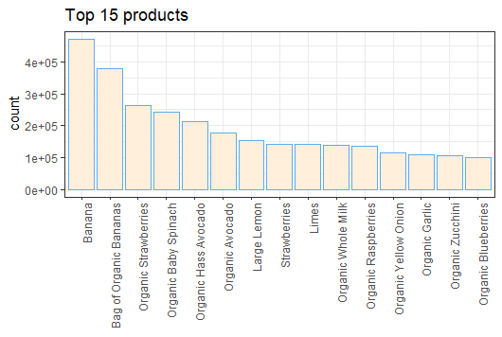

# Top 5 departments

# Count and sort the department by department names

Top5departs <- order_products_prior_pid %>%

group_by(department) %>%

summarize(count = n()) %>%

top_n(5, wt = count) %>%

left_join(select(departments,department_id,department),by="department") %>%

arrange(desc(count))

Top5departs

Top5departs %>%

ggplot(aes(x=reorder(department,-count), y=count))+ theme_bw()+

geom_bar(stat="identity",fill="darkolivegreen1",colour = "pink")+

theme(axis.text.x=element_text(angle=90, hjust=1),axis.title.x = element_blank())+ggtitle("Top 5 departments")

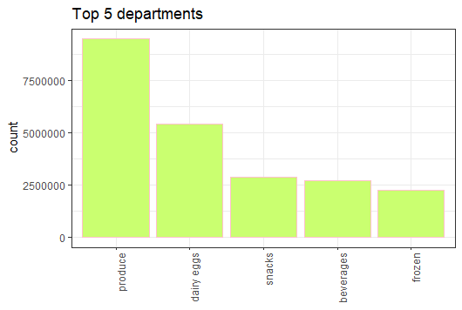

# Top 5 aisles

# Count and sort the aisles by aisle names

Top5aisles <- order_products_prior_pid %>%

group_by(aisle) %>%

summarize(count = n()) %>%

top_n(5, wt = count) %>%

left_join(select(aisles,aisle_id,aisle),by="aisle") %>%

arrange(desc(count))

Top5aisles

Top5aisles %>%

ggplot(aes(x=reorder(aisle,-count), y=count))+ theme_bw()+

geom_bar(stat="identity",fill="coral2",colour = "cyan")+

theme(axis.text.x=element_text(angle=90, hjust=1),axis.title.x = element_blank())+ggtitle("Top 5 aisles")

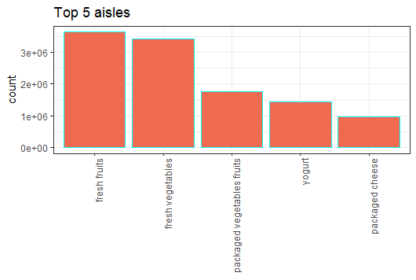

#--------------------------------------------------------------------------------------------------------

# Recommendation

# calcuating maximum order number

order_items_number <- order_products_prior %>%

group_by(order_id) %>%

summarise(number_of_items = n())

user_max_order_number <- orders %>%

group_by(user_id) %>%

summarise(max_order_number = max(order_number))

order_x <- orders %>%

inner_join(order_items_number) %>%

inner_join(user_max_order_number)

# calcuating average number of items in basket

order_latest_4 <- order_x %>%

filter(order_number + 4 >= max_order_number)

user_average_items <- order_latest_4 %>%

group_by(user_id) %>%

summarise(avg_n_of_items = mean(number_of_items))

order_product_latest_4 <- order_latest_4 %>%

inner_join(order_products_prior)

# Finding out favoured product that is reordered most

user_favor_product <- order_product_latest_4 %>%

group_by(user_id, product_id) %>%

summarise(favor = sum((reordered*9+1)*(order_number+5-max_order_number)))

user_product_rank <- user_favor_product %>%

arrange(user_id,favor) %>%

group_by(user_id) %>%

mutate(rank = rank(desc(favor)))

user_next_basket <- user_product_rank %>%

inner_join(user_average_items) %>%

filter (rank <= avg_n_of_items)

# Retrive users who reordered the favoured products

# And retrive users who would reorder the favoured products

sample_submission_user <- sample_submission %>%

inner_join(orders) %>%

select(user_id,order_id)

submission_user_next_basket <- user_next_basket %>%

inner_join(sample_submission_user) %>%

select(user_id, order_id, product_id)

submission_order_buy <- submission_user_next_basket %>%

group_by(order_id) %>%

summarise(products = paste(product_id, collapse=' '))

submission_order <- sample_submission_user %>%

left_join(submission_order_buy) %>%

select(order_id,products)

# Store results in the submission file

write.table(submission_order, file="./submission.csv", sep=",",

row.names = FALSE, quote = FALSE, na="NA")

submission = read_csv("C:/MyFiles/Kshiti/Edwisor/PROJECT/submission.csv")

View(submission)

#--------------------------------------------------------------------------------------------